FINANCIAL STATEMENTS OF THE ORGANISATION
FOR ECONOMIC CO-OPERATION AND DEVELOPMENT
AS AT 31 DECEMBER 2007
OECD
Statements of Financial Position as at
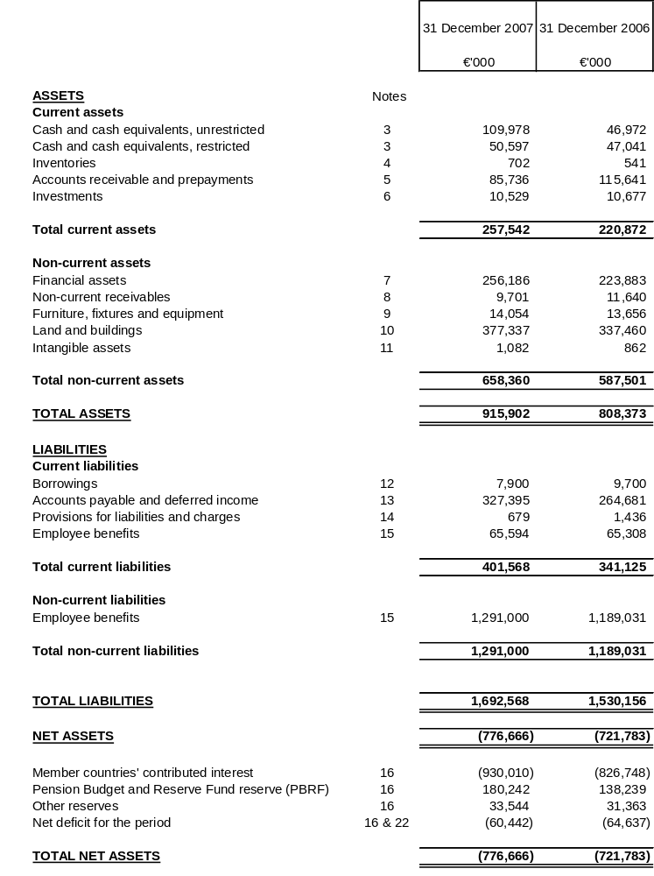
OECD
Statements of Financial Performance for the year ended
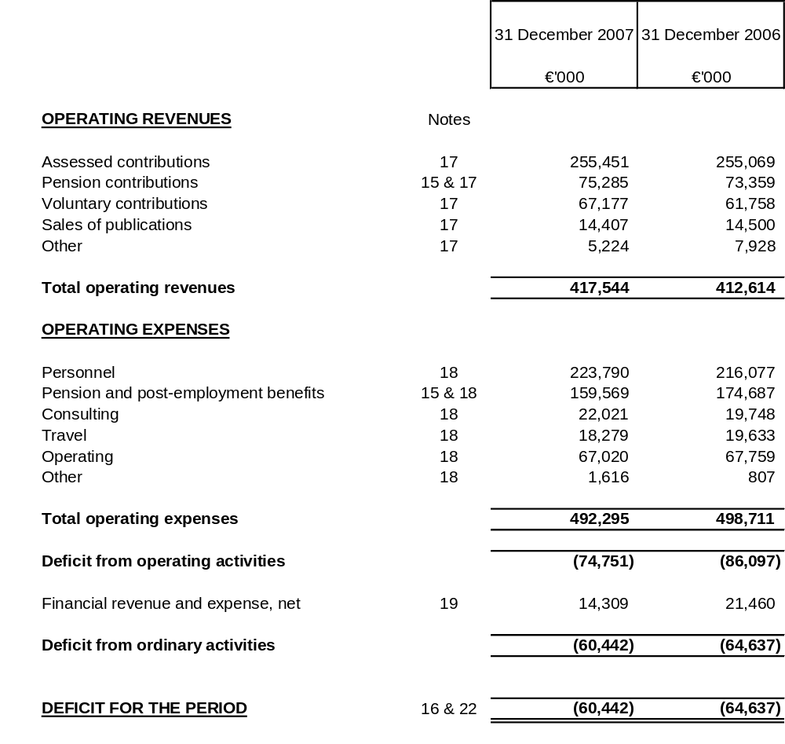
OECD
Statements of Cash Flow for the year ended
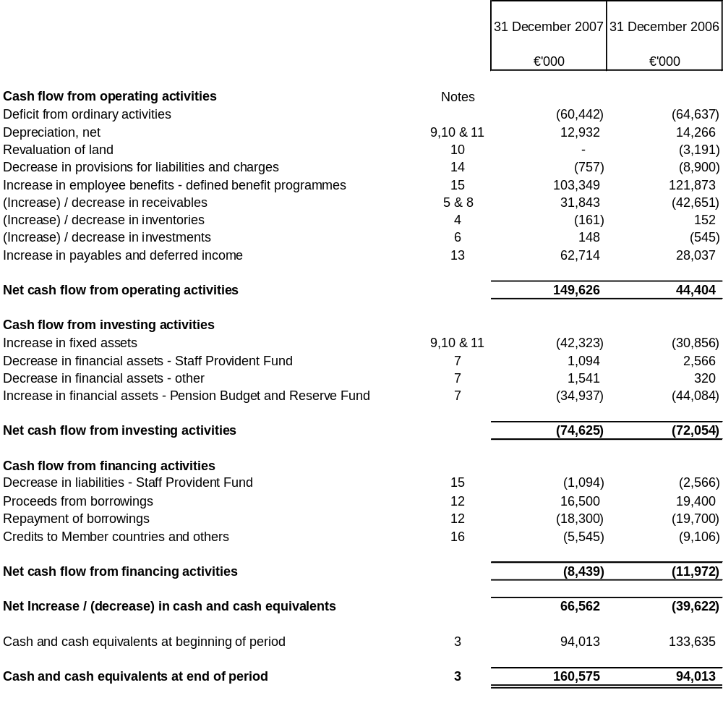
Income relating to the Site Project contributions is included in cash flow from operating activities. Additions to fixed assets relating to the Site Project are included in cash flow from investing activities.

OECD
Statements of Changes in Net Assets
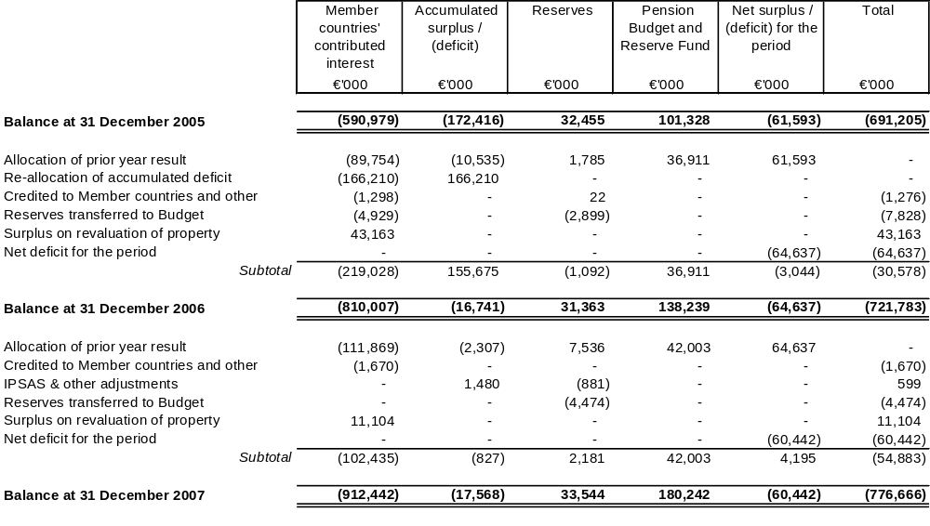
Member countries’ contributed interest includes the pension and post-employment health benefits liability, provision for removal of asbestos and the surplus on fixed assets, as detailed in Note 16.
The Pension Budget and Reserve Fund is the value of the funds’ net assets at the prior year end. The results of the fund for the current year are included in the net deficit for the period and are shown in Note 20.
Surpluses on the revaluation of property are credited directly to net assets, except to the extent that it reverses a revaluation decrease of the same asset previously recognised as an expense in the Statement of Financial Performance.

NOTES TO THE FINANCIAL STATEMENTS

Note 1: Objectives and Budget of the Organisation
The “Organisation for Economic Co-operation and Development” (the “Organisation) was founded in 1961, replacing the Organisation for European Economic Co-operation, which had been established in 1948 in conjunction with the Marshall Plan. The Organisation groups 30 member countries in an organisation that, most importantly, provides governments with a setting in which to discuss and develop economic and social policy, in line with the mission and role set forth in the Organisation’s Convention:
- Achieve the highest sustainable growth and a rising standard of living in member countries, while maintaining financial stability,
- Contribute to sound economic expansion, in member as well as non-member countries in the process of economic development,
- Contribute to the expansion of world trade on a multilateral, non-discriminatory basis in accordance with international obligations.
The Organisation is governed by a Council composed of representatives of all the member countries. The Council appoints a Secretary-General for a term of five years.
The Organisation is based in Paris, France, with representation offices in Washington (DC), Mexico, Berlin and Tokyo.
The Organisation enjoys privileges and immunities, notably that of being exempt from paying most forms of taxation.
The Organisation is funded primarily by assessed and voluntary contributions from its member countries, within the framework of a biennial Programme of Work and annual Budget.
The Budget is the act whereby Council accords the necessary commitment authorisation and makes the necessary appropriations for the functioning of the Organisation and the carrying out of its activities. It determines the amount of contributions to be paid by members after taking into account other resources of the Organisation. All the Organisation member countries fund the Budget for Part I programmes, accounting for about 80% of the consolidated Budget. Their contributions are based on a scale of contributions proportional to the relative size of their economies, with a cap of 24.975%. Part II Budgets include programmes of interest to a limited number of members or relating to special sectors of activity not covered by Part I. Part II programmes are funded according to a scale of contributions or other agreements among the participating countries. Annex Budgets are established for certain specific activities such as the Pension Schemes, Site Project and Publications.
The approval of the Budget by Council empowers the Secretary-General, subject to any special conditions established by Council:
- to commit and authorise expenditures and to make all payments to be borne by the Organisation, for the purposes assigned and within the limits of the appropriations and the commitment authority, as the case may be;
- to receive the income entered in the Budget, together with any other resources accruing to the Organisation in respect of its activities.
Over 70 non-member countries and international organisations also participate to various degrees in the Organisation’s programme of work. Non-member countries involvement in the Organisation includes participation in Part I committees, full participation in Part II programmes and as observers in various Organisation subsidiary bodies.
In November 2007 Council adopted the roadmaps for the accession of Chile, Estonia, Israel, Russia and Slovenia to the OECD Convention. Accession negotiations will take place individually between the candidate countries and the OECD Committees that handle substantive aspects of the Organisations’ work. Once the OECD Committees are satisfied that a candidate country fulfils their requirements for membership, a final decision on whether to issue an invitation for membership will be taken by Council.

Note 2: Significant accounting policies

Basis of preparation
These financial statements have been prepared on a going-concern basis and the accounting policies have been applied consistently throughout the period.
These statements have been prepared in accordance with International Public Sector Accounting Standards (IPSASs) implemented by the International Public Sector Accounting Standards Board (IPSASB), based on International Accounting Standards (IASs) and International Financial Reporting Standards (IFRSs) issued by the International Accounting Standards Board.
When the IPSASB does not include any specific standard, IFRSs and IASs are applied.

Foreign currency transactions
All assessed contributions are payable in euros. Voluntary contributions are accepted in euros and other currencies. Assets and liabilities that are denominated in foreign currencies are retranslated into euros at the exchange rate prevailing on the date of the Statement of Financial Position.
Foreign currency transactions are recorded at the exchange rate prevailing on the date of the transactions. Both realised and unrealised gains and losses resulting from the settlement of such transactions and from the retranslation at the reporting date of assets and liabilities denominated in foreign currencies are recognised in the Statement of Financial Performance.

Intangible assets
Computer software development costs recognised as assets are amortised using the straight-line method over their useful life not exceeding a period of three years.
Generally, costs associated with developing or maintaining computer software programmes are recognised as expenses when incurred. However, expenditures that enhance or extend the performance of computer software programmes beyond their original specifications are recognised as a capital improvement and added to the original cost of the software.

Tangible assets

Property, furniture, fixtures and equipment
Land and buildings are shown at fair value based on valuations prepared by independent experts at each year end reporting date. Due to the difficulty to establish a market value for this specialised asset, the fair value of the Conference Centre was estimated by management using the depreciated replacement cost of the asset. Due to the significantly different useful lives of the individual parts of property the costs have been allocated into components; structure of buildings, roofing and windows, fixtures and fittings, that are depreciated over different periods as shown below. The useful life of the component structure of buildings is adjusted to reflect significant renovation work that extends the estimated useful life of the asset. The useful life of all other components of buildings are reviewed periodically and adjusted if necessary. All other furniture, fixtures and equipment are stated at historical cost less accumulated depreciation and any recognised impairment loss.
Depreciation is charged so as to write off the cost or valuation of assets, other than land and properties under construction/renovation, over their estimated useful lives using the straight-line method on the following basis:
- Structure of buildings: 50 years
- Roofing and windows: 33 years
- Fixtures and fittings: 5-15 years
- Other fixed assets: 3-10 years

Impairment
The carrying values of fixed assets are reviewed for impairment if events or changes in circumstances indicate that they may not be recoverable. If any such indication exists, the recoverable amount of the asset is estimated in order to determine the extent of the impairment loss (if any). Any provision for impairment is charged against the Statement of Financial Performance in the year concerned.

Inventories
Inventories are stated at the lower of cost and net realisable value. Finished publications are valued at raw material, printing and distribution costs. Due to the short to medium term focus of publications a provision for depreciation is made for all of those issued prior to 2005, as well as more recent issues with inventory on hand in excess of one year’s sales volume. A provision for depreciation is made for supplies held in inventory for more than one year and in excess of one year’s consumption.

Receivables
Receivables are stated at their nominal value as reduced by appropriate allowances for estimated irrecoverable amounts.
No allowance for loss is recorded with respect to receivables related to member countries’ assessed contributions, except for exceptional and agreed technical reasons.
For all other receivables, an allowance for loss is established based on a review of outstanding amounts at the reporting date.

Investments and other financial assets
Investments and financial assets reported in the Statement of Financial Position consist mainly of investments held on behalf of the participants of the Staff Provident Fund, and of contributions by member countries to the Pension Budget and Reserve Fund. These financial assets consist of shares in investment funds and in marketable bonds. The funds may be invested in bonds, equity and derivative financial instruments based on risk and performance objectives.
The assets of the Pension Budget and Reserve Fund are recorded at fair value through the Statement of Financial Performance, whereas those of the Staff Provident Fund are not reported through the Statement of Financial Performance since they accrue to the participants. Both Funds are included in non-current assets unless management intends to dispose of the investment within 12 months of the Statement of Financial Position reporting date. At the end of each reporting period a valuation is made of the investments held by the Funds. The value is made by reference to official prices quoted on the day of valuation, excluding accrued interest from the date of the last interest payment in the case of bonds and fixed interest securities, or from contract valuations obtained from the fund manager in respect of unquoted investments. The difference between the fair market value and the book cost is recorded as unrealised portfolio gain or loss.
For purchases of investments, the book cost of each investment is calculated on the basis of the purchase price, excluding any interest accrued to the date of purchase or expenses incurred in connection with the purchase. If securities of the same issue are bought at different prices, then an average purchase price is calculated for each unit of security.
For sales or redemption of investments, the proceeds on the capital account are calculated on the basis of the sale price or amount repaid and excludes any interest accrued to the date of sale as well as all expenses incurred in connection with the sale.
For the purposes of determining the capital gains or losses on sale or redemption of investments, the sale proceeds on capital account, as determined above, is compared with the capital cost of the investment.

Financial risks
The Organisation has developed risk management policies in accordance with its Financial Rules and Regulations. The Organisation is exposed to a variety of financial risks, including market risk (foreign currency exchange and price), liquidity and credit risks. The Organisation does not use significant derivative financial instruments to hedge risk exposures.
- Foreign currency exchange risk
The Organisation receives voluntary contributions in currencies other than the euro and is exposed to foreign currency exchange risk arising from fluctuations of currency exchange rates.
Outside the euro zone, the Organisation has representation offices in the USA, Japan and Mexico with limited assets. Operating expenses paid in local currencies are generally offset by publication sale receipts in the same currency.
- Price risk
The Organisation is exposed to equity securities price risk related to investments in its pension funds.
- Liquidity risk
The Organisation may negotiate and use uncommitted bank credit facilities in the event of liquidity requirements.
- Credit risk
The Organisation has no significant credit risk since contributors are generally highly credit-worthy.

Provisions
Provisions for liabilities and charges are recognised when the Organisation has a present legal or constructive obligation as a result of a past event, and it is probable that the Organisation will be required to settle the obligation. Provisions are measured at the managements’ best estimate of the expenditure required to settle the obligation at the date of the Statement of Financial Position.

Employee benefits
In addition to a defined contribution retirement savings plan (i.e. the Staff Provident Fund which is closed to new entrants as from 1974), the Organisation operates a number of defined benefit contribution programmes, including: a pension plan, post-employment health coverage, and long service benefits.
The Joint Pension Administration Section (JPAS), (a Section that administrates the pension schemes for 6 co-ordinated organisations, of which the OECD is one), acting as the Organisation’s actuary, performs valuations of the defined benefit obligations and the related expense, which is recognised annually. The latest actuarial valuations were carried out as at 31 December 2007 using the Projected Unit Credit Method.
The Projected Unit Credit Method sees each period of service as giving rise to an additional unit of benefit entitlement and measures each unit separately to build up the final obligation.
The Organisation’s pension benefit obligations are partially funded by separately held assets. The assets of the Pension Budget and Reserve Fund and the assets of the Staff Provident Fund are held separately from all the other assets of the Organisation. The Funds’ assets may be used only to pay benefits and the Funds’ expenses.
To provide clearer information on the net employee benefits activity of the Organisation there have been some reclassification of pension contributions, as indicated below, that impact the presentation of pension contributions and pension and post-employment benefits expenses. Accordingly the Statement of Financial Performance and Notes 15, 17, 18 and 20, and comparative figures for 2006 have been restated: employee payroll contributions to the pension scheme amounting to 13 182 K€ (2006: 12 409 K€) has been reclassified from pension contributions and are reported as a reduction of total pension expense.

Revenue recognition
Assessed and voluntary contributions are recorded when these resources are approved.
Revenue from voluntary contributions is recognised up to the amount expensed in the period. The balance of unspent voluntary contributions and other revenues that relate to future periods are deferred accordingly.
Revenues from sales of publications are recognised upon shipment and revenues from sales of access to OECD statistics and electronic data are recognised upon delivery of access to the data.
Interest income is accrued on a time basis, by reference to the principal outstanding and at the effective interest rate applicable. Other revenues, including costs reimbursed by third parties, are recognised when they are acquired, either contractually, or in the absence of a contract, upon receipt.

Use of estimates
The financial statements necessarily include amounts based on estimates and assumptions by management. Estimates include, but are not limited to: fair value of land and buildings, defined benefit pension and other post-employment benefits obligations, amounts for litigations, valuation of publications sales returns, financial risk on inventories and accounts receivables, accrued charges, contingent assets and liabilities, and degree of impairment of fixed assets. Actual results could differ from those estimates. Changes in estimates are reflected in the period in which they become known.

Note 3: Cash and cash equivalents
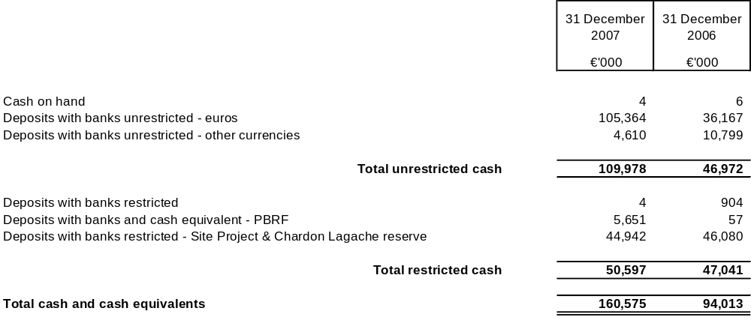
Cash deposits are generally held in instant access interest-bearing bank accounts. Interest-bearing bank accounts yielded interest at an average rate of 3.9% (2006: 2.7%).
Certain cash deposits are designated for specific uses:
- The Funds received from member countries for the Site Project (see Notes 10 and 23) together with funds that relate to the Suchet reserve (see Note 16) are specifically earmarked for the Site Project;
- The cash deposits of the Pension Budget and Reserve Fund are restricted to the payment of certain pension benefits and Fund expenses as defined by the Fund Statutes.
The Organisation has no confirmed credit lines but does maintain limited and informal overdraft arrangements with its relationship banks. These arrangements may be withdrawn by the banks at any time. No overdraft facilities were required in 2007 (2006: none).

Note 4: Inventories
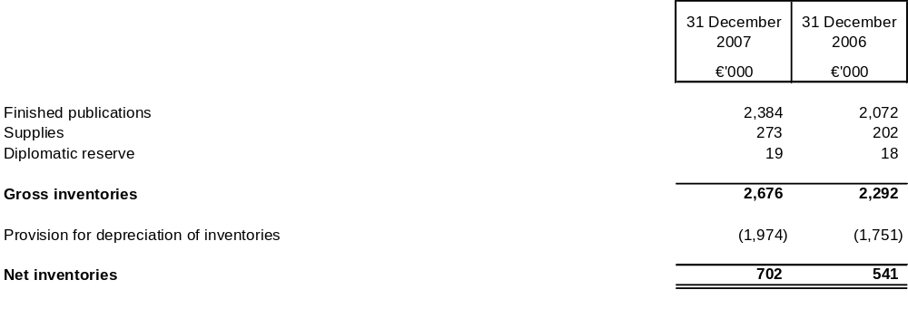
Finished publications include publications held for sale and publications issued free of charge.
Supplies include printing papers for publications stocked at the Organisation and on consignment at a supplier’s warehouse.
The provision for depreciation of inventories represents the write down of inventories of finished publications and supplies to net realisable value.

Note 5: Accounts receivable and prepayments
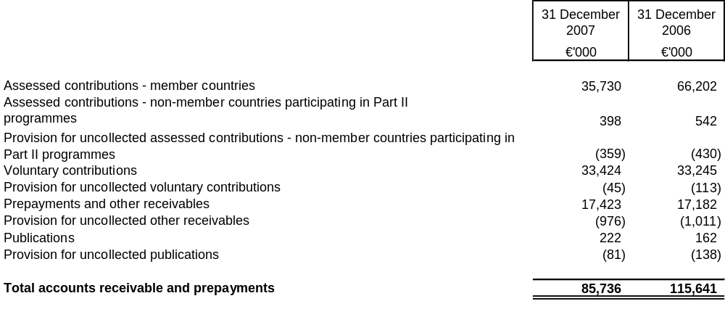
Assessed and voluntary contribution receivables represent uncollected revenues committed to the Organisation by member and non-member economies and donors for completion of the Programme of Work.
Prepayments and other receivables are mainly in respect of advance payments made to suppliers, principally related to the Site project, 3.0 M€ (2006: 6.7 M€), reimbursable taxes 7.2 M€ (2006: 7.0 M€), receivables from the accession countries and from member countries for various services rendered, including office rental and staff costs.
The non-current Part of voluntary contributions covering future periods is reported in non-current receivables (see Note 8).

Note 6: Investments
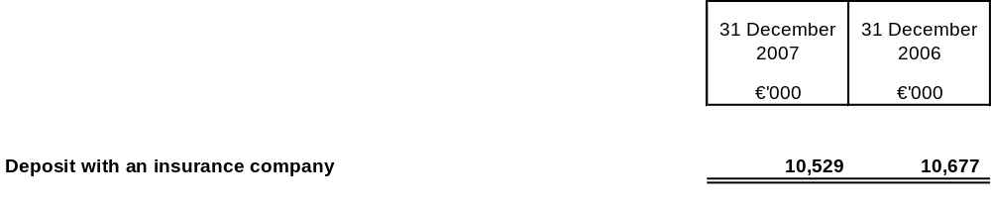
The deposit with an insurance company corresponds to the funding of the medical plan reserve (see Note 16). It is restricted to cover the cost of the claims administration and the risk of variation in costs associated with the health insurance contract for the Organisations’ staff and retirees. Under the terms of the contract, the insurance company manages the deposit in an investment account. The investment is denominated in euros and stated at nominal value plus accumulated interest. The movement in the deposit results from the difference in medical contributions and medical costs, claim administration cost and interest earned on the fund at an estimated rate of 3.9% (2006: 4.5%). In January 2008 the deposit was repaid to the Organisation and invested in short-term bank deposits.

Note 7: Financial assets – non-current
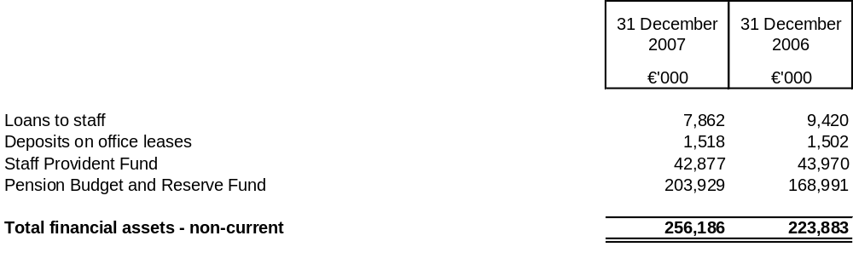
- Loans to staff are financed by a short-term bank borrowing of 7.9 M€ (2006: 9.7 M€). The interest rate charged to staff loans is adjusted semi-annually, on the basis of the rate charged by the bank, plus a margin towards funding loan administration expenses. Collections are assured through payroll withholding and staff separation payments.
- Deposits on office leases are guarantee deposits made by the Organisation as collateral related to the fulfilment of the Organisations’ obligations under operating lease agreements.
- The Staff Provident Fund is a defined contribution retirement savings plan. In accordance with the Fund’s rules, it constitutes a segregated entity managed by the Secretary-General on behalf of affiliated employees and retirees. The Fund collects contributions from the affiliated employees of 7% and from the Organisation of 14% of salaries, manages its assets and pays entitlements to its participants. The assets and liabilities of the Fund are reported globally in the Statement of Financial Position. Revenues and charges are not reported in the Statement of Financial Performance since they accrue to the participants. The Fund was closed to new entrants in 1974 when participants were given the choice of remaining in the Fund or using their accumulated account balances to buy rights to prior years of service on an actuarial basis in the Organisation’s newly created defined benefit pension plan. The Staff Provident Fund participants at 31 December include 46 serving staff (2006: 61) and 271 retired staff (2006: 277). In 2006 the administration of the fund was transferred to the JPAS. An investment included in the monetary funds category was suspended from trading during 2007 and will be liquidated in 2008. The investment was valued at the period end at 2 256 K€, using the estimate provided by the fund manager. The amount that will be finally realised from this investment is uncertain.
Changes in the Staff Provident Fund investments during the period were as follows:
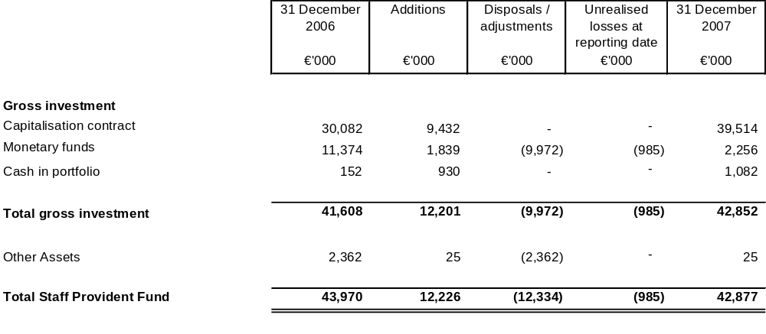
- In 2000, the Organisation created the Pension Reserve Fund to “smooth out member countries’ contributions over time, provide financial stability to the Organisation’s programme of work, introduce investment income as a complement to staff and member country contributions, and, with regard to future service, meet the concerns which have arisen about the distribution of the financial burden of pensions related to past service.” In 2005 Council carried out a thorough review of the Fund and agreed to: change the name of the Pension Reserve Fund to Pension Budget and Reserve Fund; segregate the funding for pensions from other flows of funds including through the use of special(s) account(s) with custodian(s) bank(s) to receive payments from member countries and staff and to continue a long-term financing structure in order to progressively increase the percentage of pension liabilities which are funded.
Changes in the Pension Budget and Reserve Fund investments during the period were as follows:
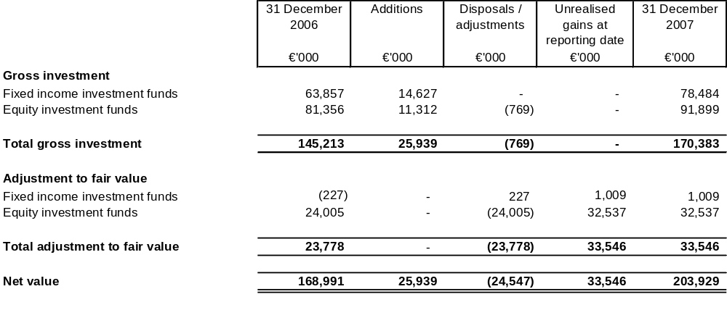
The Pension Budget and Reserve Fund is restricted to pay the pension benefits of staff and is managed according to its statutes. The investment objectives for the Fund recognise the long-term nature and the type of liabilities under the Pension Plan. The Fund invests approximately 60% of its long-term assets in equity funds with the remaining balance in fixed income funds. This long-term strategic position is designed to maximise total return subject to controls over credit and liquidity risk and reduce volatility. Due to the equity component of the portfolio the investments follow, nevertheless, short term fluctuations in financial markets. Unrealised gains and losses on Investments are recognised in the Statement of Financial Performance. The revenue and expenses of the Fund are presented in Note 20: Segment information – Statement of Financial Performance.
- The Staff Provident Fund and the Pension Budget and Reserve Fund are exposed to the financial risks of changes in foreign currency exchange rates, in interest rates and in market price related to investments. Securities held by the two funds are denominated mainly in euros to minimise foreign currency exchange risk. To cover the specific short-term liability for current year pension benefit payments, a portion of the funds’ assets are held in bank deposits.

Note 8: Non-current receivables
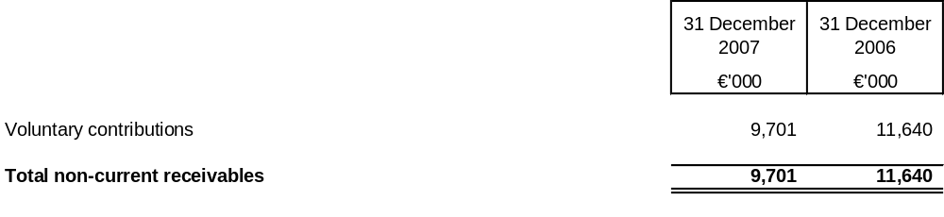
Non-current voluntary contributions are due after more than one year in accordance with the terms of the offers.

Note 9: Furniture, fixtures and equipment
Changes in furniture, fixtures and equipment for the period were as follows:
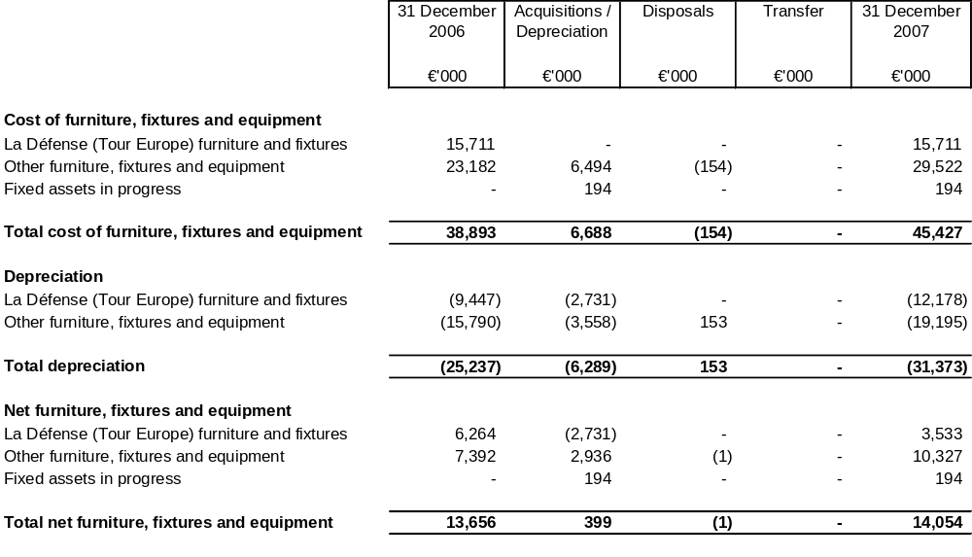
The investment in La Défense (Tour Europe) furniture and fixtures is related to the relocation of personnel due to the Site Project. Details of the operating lease commitment are shown in Note 23.
The major acquisitions during the year are related to the fitting out of the new conference centre.

Note 10: Land and buildings
The Organisation’s land and buildings are comprised principally of its headquarters at La Muette, Paris.
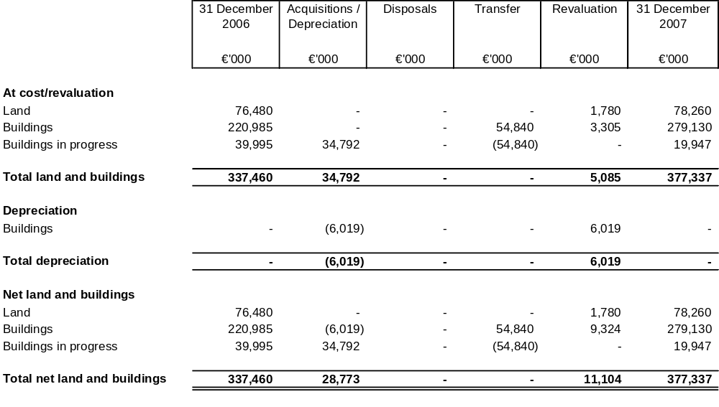
In January 2000 Council decided to renovate the La Muette headquarters buildings: the current Site Project. This includes:
- Renovation and upgrading of the Chateau to modern norms;
- Asbestos removal and renovation of the New Building and Pascal wing, without modification of the structure;
- Construction of a new Conference centre.
During the construction and renovation period a number of staff have been temporarily relocated to rented premises, the majority of them to Tour Europe in La Défense.
The total cost of the Site Project is reported in Note 23B, Capital commitments. Construction/renovation costs are accumulated under “Buildings in progress” for each building until the construction/renovation is completed and duly accepted by the Organisation.
The Site Project is financed by contributions from member countries.
The Site Project is due for completion by the end of 2008. The Chateau was operational again in the first quarter 2006 and the cost of renovation is now reported in Buildings. The construction of the Conference Centre, including staff restaurant facilities, was completed during the 4th Quarter 2007, and the relevant costs have been transferred from buildings in progress to Buildings. Due to the difficulty to establish a market value for this specialised asset, the fair value of the Conference Centre was estimated by management using the depreciated replacement cost of the asset. In this context, its actual cost as at 31 December 2007 (54.8 M€) is considered by management as representative of its depreciated replacement cost.
The cost of the works contracted and completed at the reporting date for the renovation of the New Building are reported as buildings in progress as detailed below:
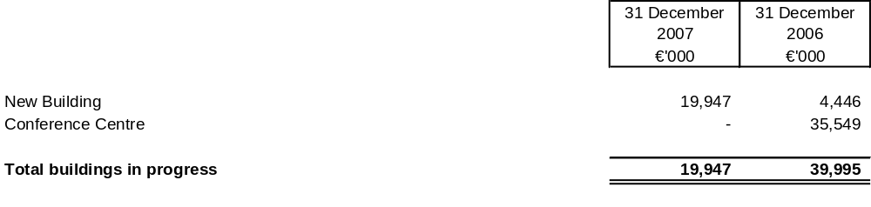

Revaluation
Land and buildings that are carried at fair value have been revalued on the basis of their fair market value at the period end date.
The cumulative effect of these operations have been recognised as follows:
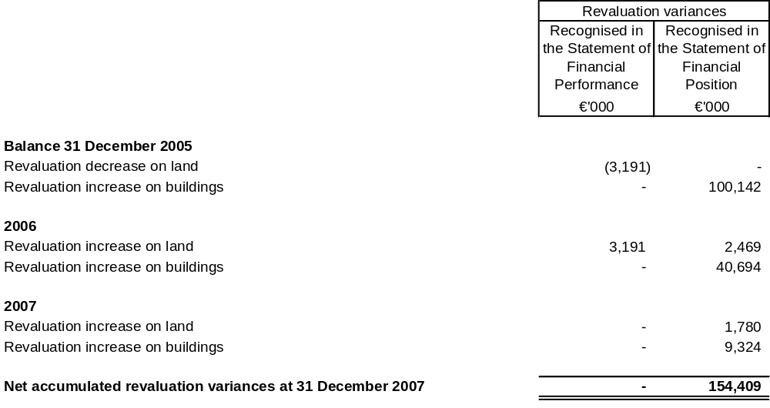
A revaluation increase is normally recognised in reserves in the Statement of Financial Position. However, to the extent that it reverses a revaluation decrease previously recognised as an expense, a revaluation increase is recognised as income in the Statement of Financial Performance. Prior period revaluation losses on land have been fully recovered at the end of 2006.

Note 11: Intangible assets
Intangible assets consist of purchased software.
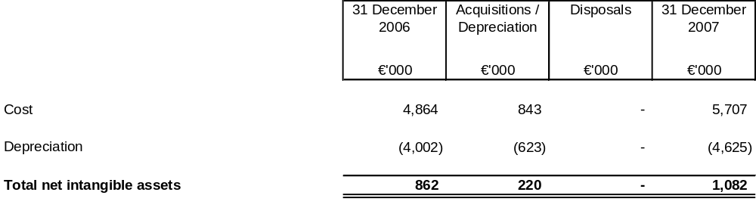

Note 12: Borrowings
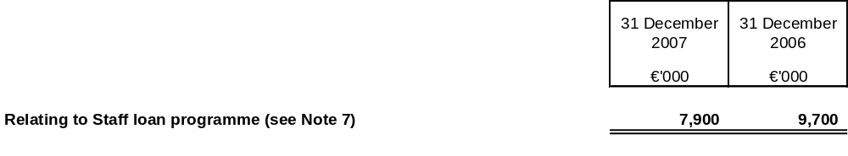

Note 13: Accounts payable and deferred income
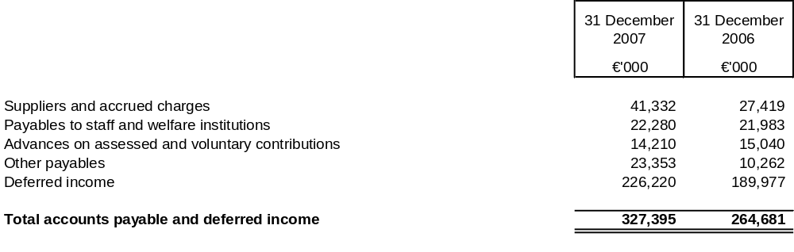
Suppliers and accrued charges include invoices received from suppliers not yet settled and obligations to suppliers for services performed not yet invoiced. Accrued charges amount to 22.1 M€ at 31 December 2007 (2006: 17.0 M€). The change in suppliers from 2007 over 2006 is due mainly to the advancement of the Site Project. A total amount of 5.3 M€ (2006: 1.6 M€) has been retained from various contractors as guarantees against the Site Project work.
Payables to staff primarily represent accrued vacation and other compensated absences and other payments due to staff. Payables to welfare institutions are current contributions, the most significant of which is in respect of the health insurance contract.
Other payables consist of budget surpluses, amounting to 5.2 M€ (2006: 5.1 M€), and advance payments for special projects and from countries on the roadmap to accession to the Organisation. The increase compared to 2006 is mainly due to advance payments from the accession countries. The budget surpluses are credited to an account attributable to each member country after they are approved by Council and are then available for any use that the individual member country may decide. All surpluses until end 2006 have been approved by Council.
Deferred income corresponds to revenues recorded but for which corresponding charges will be incurred after the reporting date. They consist of:
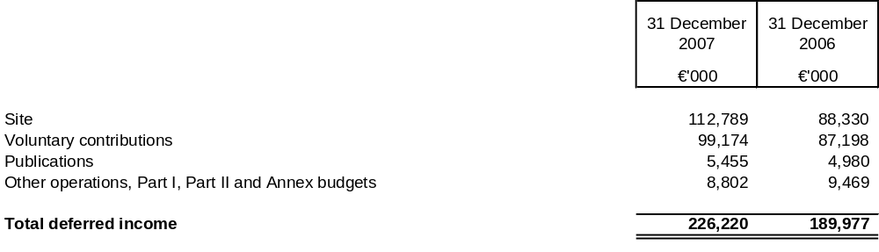

Note 14: Provisions for liabilities and charges
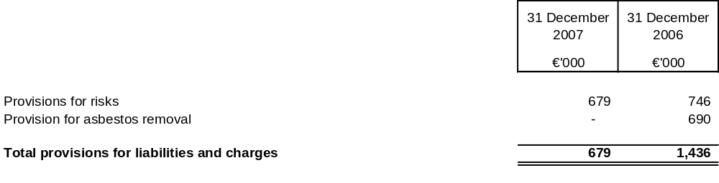
Provisions for risks represent the evaluation at the closing date of payments to be made in respect of various litigations to which the Organisation is party and the cost of publication sale returns from distributors.
The provision for asbestos removal has been fully utilised and the asbestos removal work was completed as scheduled during the 1st Quarter 2007.

Note 15: Employee benefits
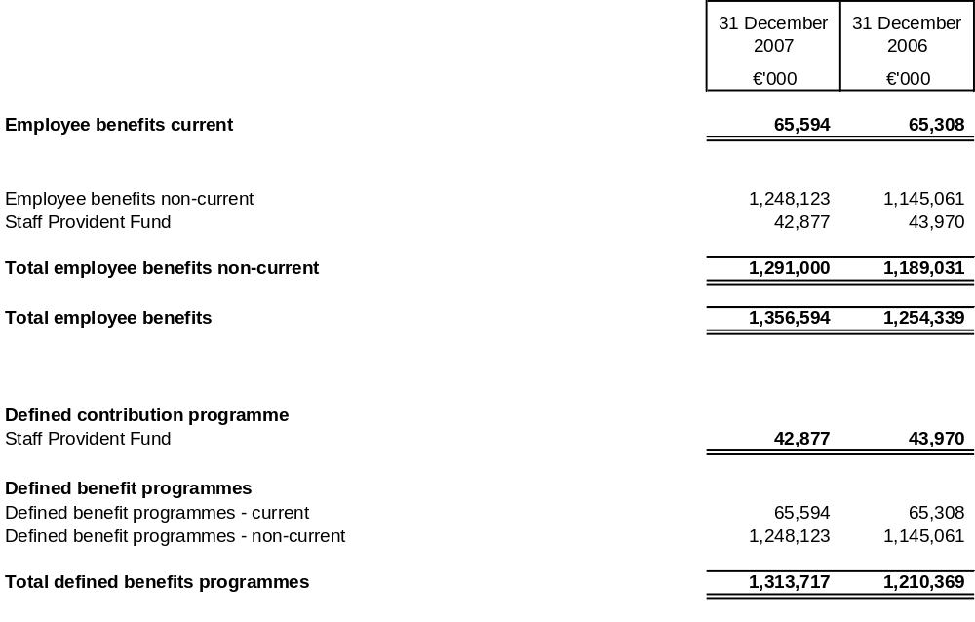
Staff Provident Fund represents the offsetting liability of the Funds’ assets described in Note 7.
Employee benefits represent the estimated actuarial liability of defined benefit programmes for retirement benefits, post-employment health coverage and long service benefits.
The Organisation operates defined employee benefit plans that include a pension plan coordinated with five other international Organisations, a revised pension plan for employees hired after 1 January 2002, post-employment health coverage and a long service benefit plan applying to a closed group of employees.
The long service benefit plan was closed to new entrants in 1993 and has 665 eligible employees (2006: 701).
The Organisation offers to retirees the same health coverage than for the active staff through three different contribution schemes.
In 2006 the Organisation reviewed its main financial actuarial assumptions: discount rates, future salary and benefit levels and future medical costs. All demographic assumptions are reviewed at least every five years and the last review was in 2003.
The Organisation performs annually both a long term projection and an actuarial valuation of the various defined benefit schemes in force at the reporting date to measure its employment benefits obligation.
The following tables set out the changes in the accumulated benefits obligation and the amounts recognised in the Statements of Financial Position and the evolution of actuarial assumptions:
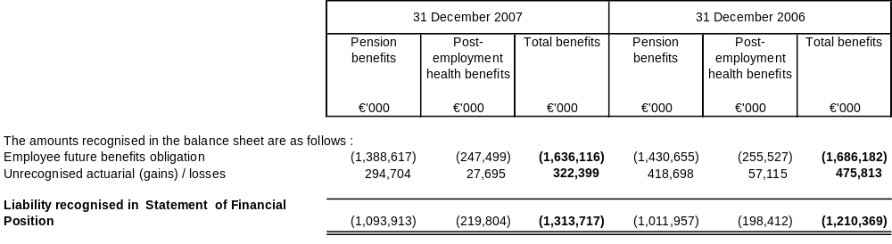
The actuarial valuation of the defined benefits obligation is determined by discounting the probable future payment required to settle the obligation resulting from employee service rendered in the current and prior periods. The discount rate used is based on market yields, at the reporting date, on euro denominated French government bonds that have terms to maturity approximating to the terms of the related pension liability.
The increase in the discount rate at 31 December 2006 and 31 December 2007 for pension benefits, from 4.1% to 4.7%, and post-employment benefits, from 4.1% to 4.6%, is the main reason for the decrease in the 31 December 2007 employee future benefits obligation of approximately 42 M€ and 8 M€ respectively over 2006.
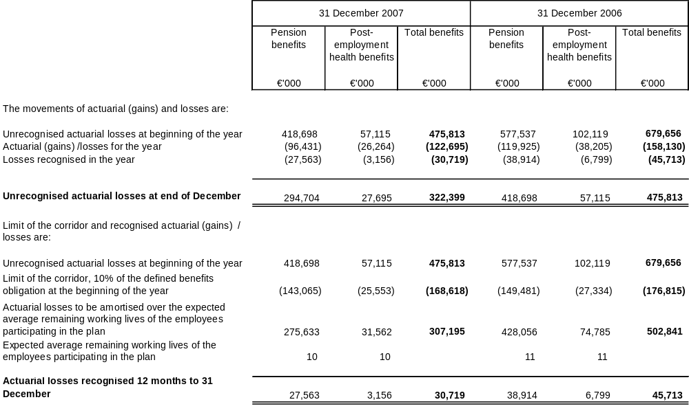
Actuarial gains or losses arise when the actuarial assessment differs from the long term expectation on the obligations: they result from experience adjustment (difference between the previous actuarial assumptions and what has actually occurred) and the effects of change in actuarial assumptions.
Actuarial gains or losses are accounted for using the “corridor method”. Actuarial gains and losses are recognised in the Statement of Financial Performance to the extent that they exceed 10% of the greater of the fair value of the plan assets or the present value of the gross defined benefit obligations in the scheme at the beginning of the period. Actuarial gains and losses exceeding 10% are amortised over the expected average remaining working lives of the employees participating in the scheme, 10 years in 2007 (2006: 11 years).
The amounts recognised in the Statements of Financial Performance are as follows:
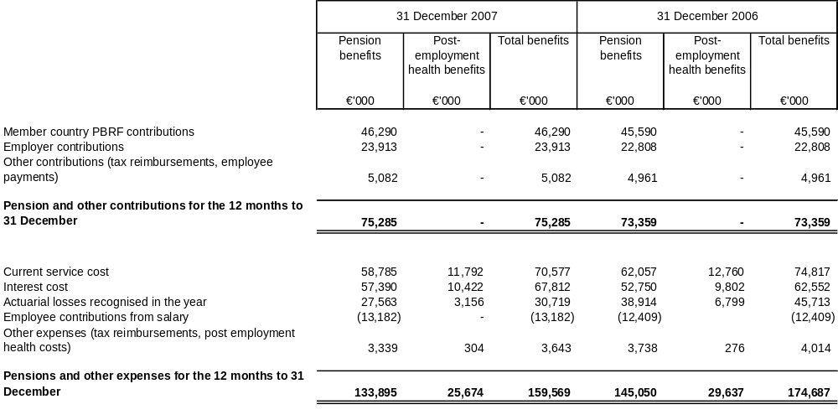
Current service cost is the increase in the present value of the defined benefit obligation resulting from employee service in the current period.
Interest cost is the increase during the period in the present value of the defined benefit obligation which arises because the benefits are one period closer to settlement.
In 2007, employee payroll contributions to the pension scheme amounting to 13 182 K€ that were reported as pension contributions are now reported as a reduction of total pension expense. The 2006 amount of 12 409 K€ has been restated to reflect this change.
Changes in the present value of the employee future benefits obligation are as follows:
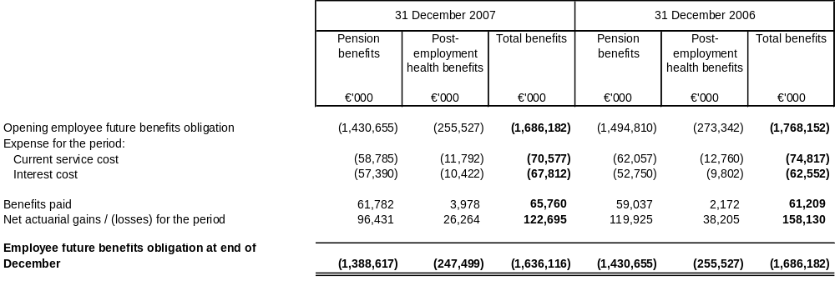
Principal actuarial assumptions at 31 December (expressed as weighted averages) were:
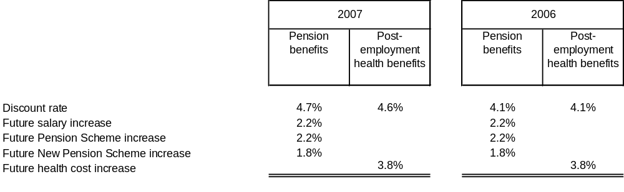
Assumed healthcare cost trends have a significant effect on the amounts recognised in the Statement of Financial Performance. A one percentage point change in assumed healthcare cost trend rates would have the following effects:
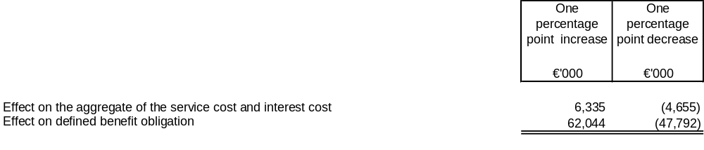

Note 16: Member countries’ contributed interest and reserves
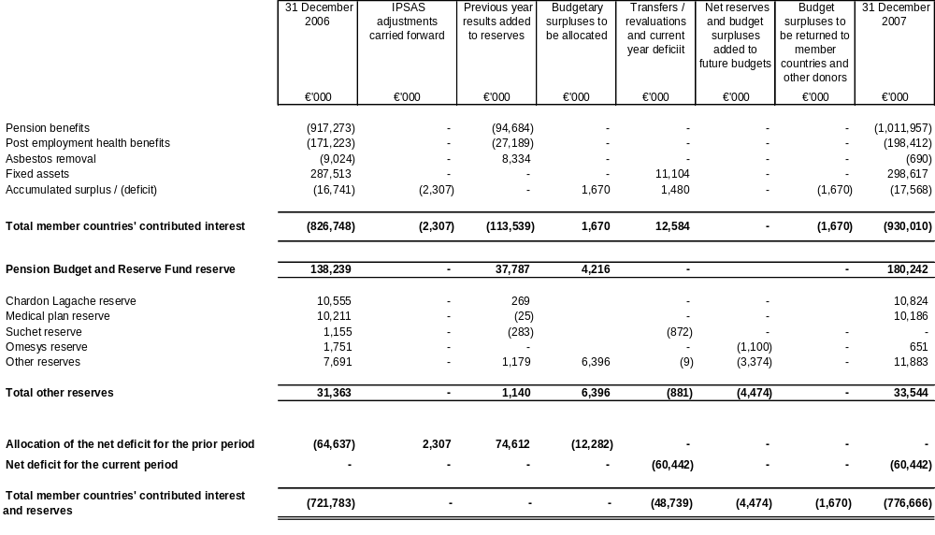
Member countries’ contributed interest represents: the liability related to the pension benefit obligation and post-employment health benefits, detailed in Note 15; the provision for the removal of asbestos from buildings included in the Site Project; and the counter Part of land and buildings owned by the Organisation.
The balance shown at 31 December 2007 for pension benefits, post-employment health benefits, asbestos removal and the Pension Budget and Reserve Fund are the value at the prior year end as the movements for the current year are included in the net deficit for the current period.
The accumulated surplus/(deficit) results from IPSAS accounting differences carried forward.
The reserves Chardon Lagache, medical plan and Omesys, correspond to funds to be used for purposes specified by Council or by the Secretary-General. The Suchet reserve has been fully utilised to partly finance the Site Project.
Other reserves represent net surpluses retained for future use.

Note 17: Operating revenues
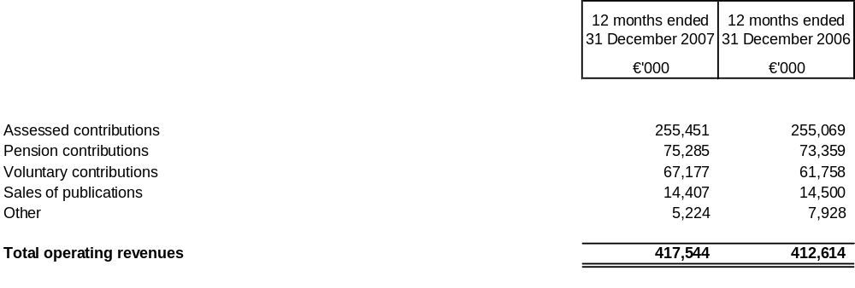
Main variances between 2007 and 2006 are as follows:
- Assessed contributions for Part I, Part II and Annex budgets increased in line with the Annual Budget, more than offsetting lower revenue for the Site Project;
- Pension contributions include amounts paid by member countries to the PBRF fund, employer contributions, other contributions of tax reimbursements and employee payments. In 2007 employee contributions to the pension scheme amounting to 13 182 K€ have been reclassified from pension contributions to pension costs. The 2006 amount of 12 409 K€ has been restated to reflect this change;
- Voluntary contributions recognised during the period were higher due to increased contributions from member countries and non-member economies and additional programmes of work;
- Other revenues include costs reimbursed by third parties, recovery of salaries of seconded staff, revenue from non-member economies and receipts from conferences.

Note 18: Operating expenses
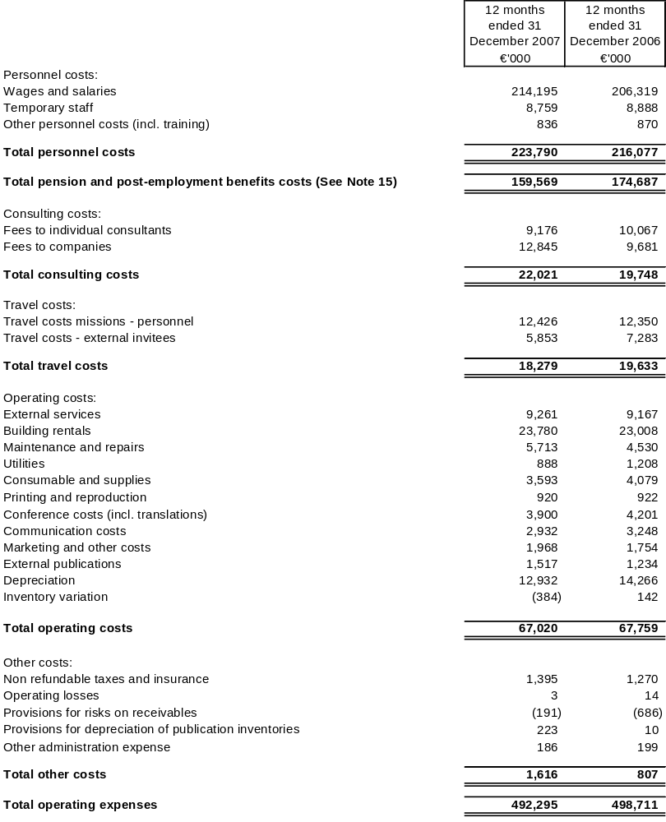
Main variances between 2007 and 2006 are as follows:
- The increase of 3.6% in personnel costs is partly due to additional programmes of work. In 2007 an amount of 1 762 K€, related to temporary staff employer payroll charges (2006: 1 802 K€), that were reported in wages and salaries, are now reported in temporary staff. Prior year comparative figures have been restated accordingly;
- The reduction in pension and post-employment benefits costs is due to mainly to the decrease in actuarial losses recognised in the period of 15.0 M€. In 2007, employee payroll contributions to the pension scheme amounting to 13 182 K€ that were reported as pension contributions are now reported as a reduction of total pension expense. The 2006 amount of 12 409 K€ has been restated to reflect this change;
- Consulting, travel and conference costs increased by 618 K€, 1.4%, due mainly to the increase in voluntary contributions;
- The decrease in depreciation in 2007 is due mainly to the accelerated depreciation in the 1st Quarter 2006 of components of the New Building that were taken out of service for renovation. The work commenced during the 1st Quarter 2006 and is scheduled for completion in 2008.

Note 19: Financial revenue and expenses
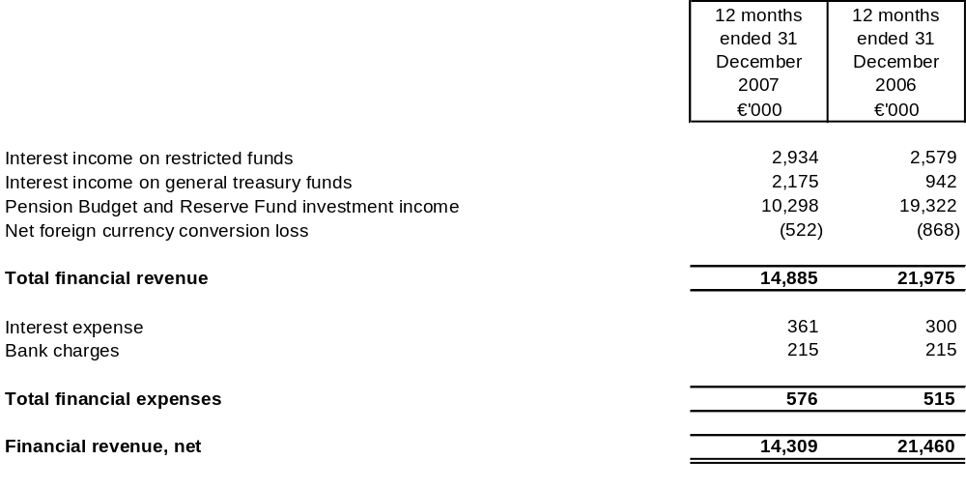
Interest income increased by 1 588 K€ due to increased interest yielding deposits and higher interest rates.
Interest income on general treasury funds is earned mostly from voluntary contributions received in advance of the related expenditure.
Net foreign currency losses are lower due mainly to maintaining lower bank balances in non-euro bank accounts.
Interest expense is mainly for the borrowings used to fund the staff loan programme.

Note 20: Segment information - Statement of Financial Performance
Segment information is based on the principal activities and sources of financing of the Organisation. These service segments conform to the Programme of Work of the Organisation for the years 2006 and 2007. Budget Title I - Part I is for programmes financed by all members and Budget Title I - Part II is for special programmes financed by some or all members. Title II, Title III and Annex budgets include the Site Project. Pension activity in 2007 is reported in Pension Budget and Reserve Fund whereas in 2006 pension activity was reported in the Annex budgets and the Pension Budget and Reserve Fund. The amounts shown for 2006 have been restated for this change. Non-budgetary operations include staff loans, exchange variances and other sundry operations.
Owing to the nature of the activities of the Organisation, its assets and liabilities are jointly used by the segments, and are not separately disclosed.
The following table combines budgetary and IPSAS reporting. IPSAS adjustments are accounting entries required to conform to IPSAS and are not Part of the Organisations’ budgetary reporting. These adjustments principally concern accrual accounting relating to expenses and revenues, pension benefits and other personnel costs, fixed assets and related depreciation. When possible, accrual adjustments are allocated to revenues and expenses by segment. IPSAS accrual adjustments that are not allocated to a specific segment are reported in the “IPSAS” column. Internal operations reflect the estimated cost of services exchanged between segments.
Statement of Financial Performance by Segment
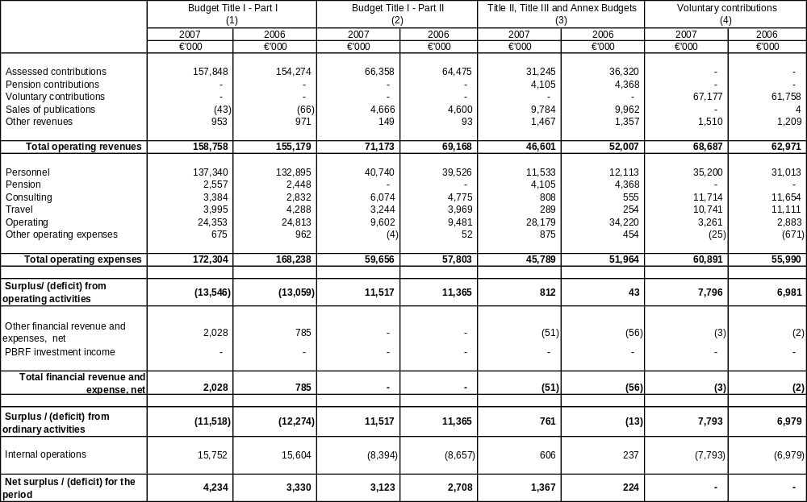
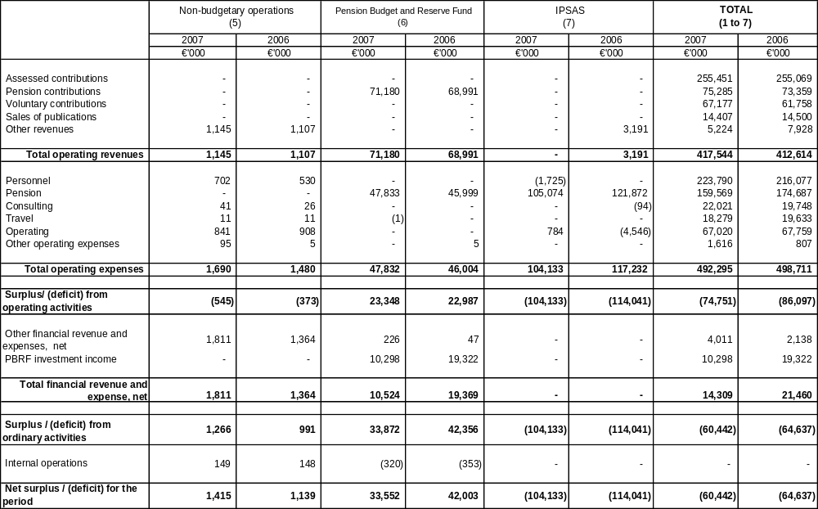

Note 21: Reconciliation of budgetary results and results after IPSAS adjustments for the period
In order to reconcile the budget outturn results to the results after IPSAS adjustments for the period differences between budget accounting and accrual accounting need to be taken into account. These differences can be attributable to timing or permanent differences. The most significant of these differences are the following:
- In budget accounting, revenue is required to cover all committed expenditures. In accrual accounting, revenue and expenses only includes amounts corresponding to amounts accruing to the period. The difference is treated as deferred revenue or expenses in accrual accounting.
- In budget accounting, capital expenditures (except capital expenditures for the Site Project which has a separate budget) are recorded as current year expenses. In accrual accounting this expense is capitalised and depreciated over the useful lives of the assets. These capital expenditures and associated depreciation are recorded at their net value as assets in the Statement of Financial Position. Depreciation expense is recorded in the Statement of Financial Performance.
- In budget accounting expenditure for employee benefits is accounted for on a pay as you go basis. In accrual accounting, the expense is estimated by an actuary in accordance with a methodology set out in accounting standards. The pension and post-employment benefits obligation is reported in the Statement of Financial Position as detailed in Note 15.
- In budget accounting publications receipts, including subscriptions, are recorded during the year on a cash basis. In accrual accounting these sales are recorded as revenue when delivered and adjusted by provisions for losses on receivables or returns of goods sold.
The following table shows the budgetary results reconciled with the results after IPSAS adjustments for the period as reported in the financial statements.
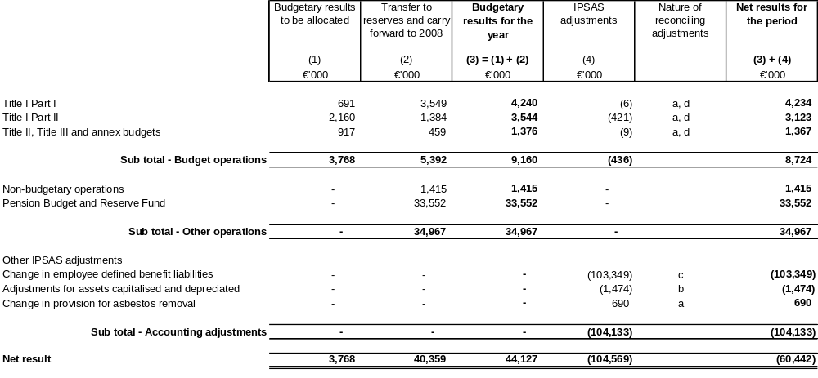

Note 22: Proposed allocation of the results for the period
The results for 2007 will be allocated as follows, subject to approval by Council:
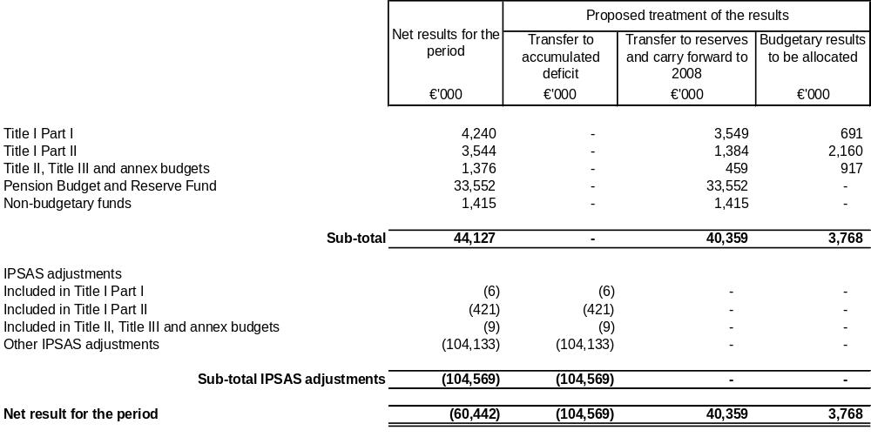

Note 23: Contingencies and capital commitments

A. Contingencies
The Organisation is or may be a party to a limited number of legal proceedings or technical disputes. Management believes that the liabilities that might result from these litigations will not be material in relation to the Organisation’s operations or financial position.
In 2002, the Organisation signed a lease for office space in La Défense covering the period 2002-2011. In the event that the lease would be cancelled before its current end date, the Organisation would be liable to pay penalties depending on the notice of cancellation given. In accordance with the present schedule of the Site Project, which provides for the vacation of the leased premises in 2009, the sum of 8 625 K€ has been included in the 2001-2009 Site Budget that was voted by Council in 2003.
In 2002, the Organisation set up an early retirement scheme for a closed group of employees that had been exposed to an asbestos risk. The scheme allows the employees to request early retirement providing they are over 50 and under 60 years of age, and certain conditions as to job function and medical condition are met. At 31 December 2007 one employee was receiving early retirement payments under the scheme. In the unlikely event that all the remaining eligible employees benefited fully from the scheme the maximum amount payable would be approximately 4.3 M€ over the period to June 2031.

B. Capital commitments
- Site Project
The Site Project consists of the renovation of the La Muette site in Paris, where the Organisation is headquartered since its creation. The overall operation, in addition to a large-scale asbestos removal, comprises large redevelopment, demolition and construction works. The Organisation will at the same time reconfigure its conference facilities.
The total Site project cost is estimated at 298.5 M€ and includes all costs related to the temporary relocation of staff over several years. At 31 December 2007 the budget situation of the Site Project is:
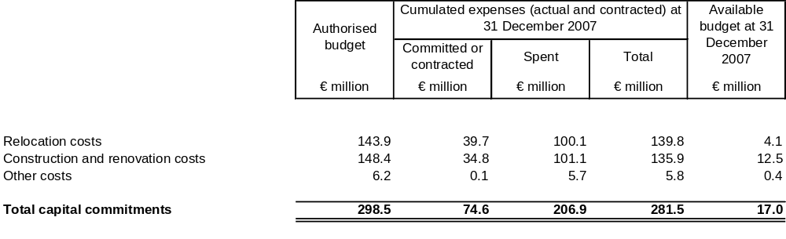
- Operating lease commitments
Future minimum lease rental payments for the following periods are:
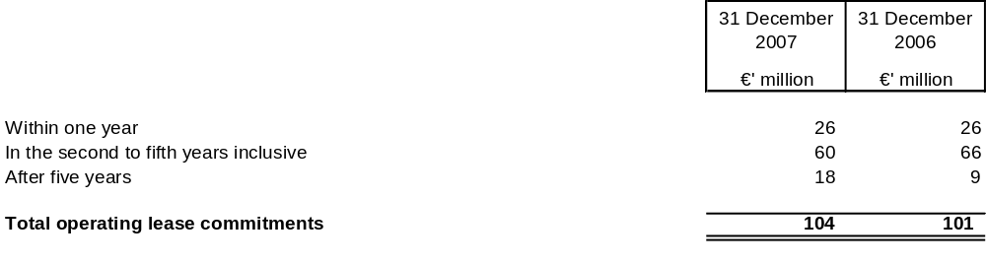
Operating lease payments represent rental payments for certain properties. The rents payable under these leases are subject to renegotiation at various intervals specified in the lease contracts. As noted above in contingencies, the lease for office space in La Défense, covering the period 2002-2011, has a penalty clause in case of cancellation before the contracts’ current end date.
- Bank guarantee
The Organisation’s obligations to lessors of office premises are guaranteed by banks for a maximum of 3.7 M€. The most important one applies to the La Défense offices for 3.6 M€ over the duration of the lease.
- Pensions
The Organisation’s defined benefit pension plan was adopted by a Council Resolution of 16 November 1976 (C/M(76)20 Final). This Resolution constitutes a decision binding upon the Organisation and its member countries by virtue of articles 5 a) of the Convention on the Organisation and 18 a) of its Rules of Procedure. The Organisation believes that this creates both a legal obligation upon the Organisation towards pensioners and staff and an offsetting legal obligation for the member countries, with the same full legal force as the treaty from which it derives, to contribute amounts needed to pay the pensions. Article 40 of the defined benefit pension plan confirms that pensions are a charge on the Organisation’s budget, and provides a joint guarantee of that liability by each of its member countries. That guarantee is equivalent in amount to the accrued pension obligation at 31 December 2007 of 1 389 M€ (2006: 1 431 M€), as shown in Note 15. The member countries participate in the progressive constitution of a fund (Pension Budget and Reserve Fund) towards this liability. The net value of the financial assets of the fund at 31 December 2007 was 203.9 M€ (2006: 169.0 M€).

Note 24: Related party transactions
The Organisation is governed by a Council composed of representatives of all the member countries. They do not receive any remuneration from the Organisation. The Council is presided over by the Secretary-General who directs the Secretariat, assisted by Deputy Secretary-Generals and other senior managers and officers (key management personnel). They are remunerated by the Organisation.
The Organisation is under the direct control of the member countries. It has no ownership interest in associations or joint ventures.
There were no material transactions with related parties during the years 2007 and 2006.
Key management personnel and their aggregate remuneration were as follows:
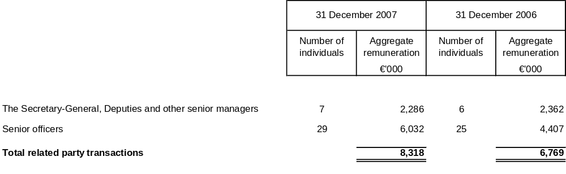
There were no loans to key management personnel and their close family members which were not available to other categories of staff. There was no other remuneration and compensation to key management personnel and their close family members.

